***FLOOD PREDICTION MODEL***

***Introduction:***

Floods are considered as the most common natural disaster on Earth.

Floods have become the most well-known And fatal disaster events of this century. Absence of a successful flood forecasting framework has brought about grave loss of human existence and infrastructure.

This model focuses on improving the rate of prediction.

A flood happens when water submerges land that is normally dry, which can happen in an enormous number of ways. Brisk liquefying of ice, outlandish rainfall or a burst dam, can overwhelm a river, spreading over the contiguous land.

***DataSet:***

This model helps predict the floods in the Kerala.The data points collected from the year 1901-2018. We can download the dataset from Kaggle website.

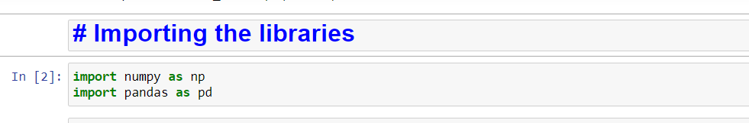

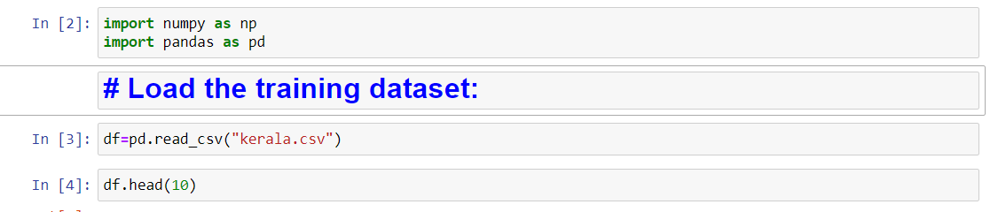

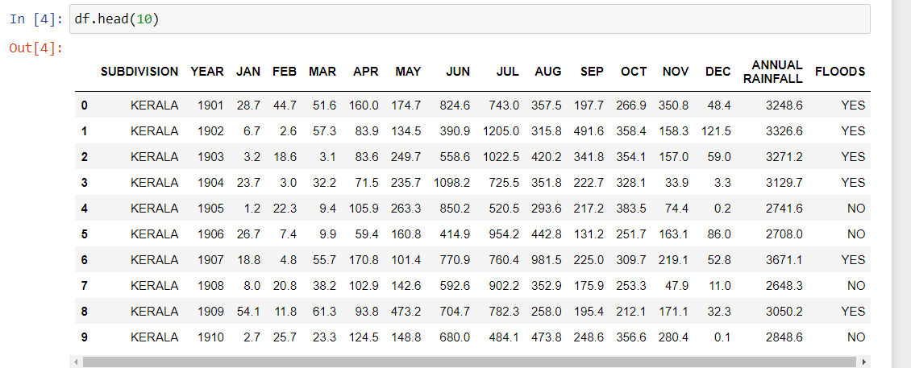

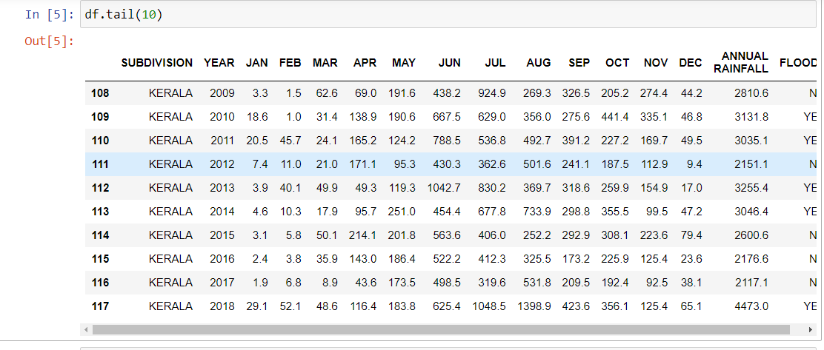

This is the data set. In this we have 16 columns and 118 rows.

The dependent variable “floods” have YES or NO values only. i.e a variable have that has only two outputs. So we use LOGISTIC REGRESSION.

LOGISTIC REGRESSION:

logistic regression is also used **to estimate the relationship between a dependent variable and one or more independent variables**, but it is used to make a prediction about a categorical variable versus a continuous one.

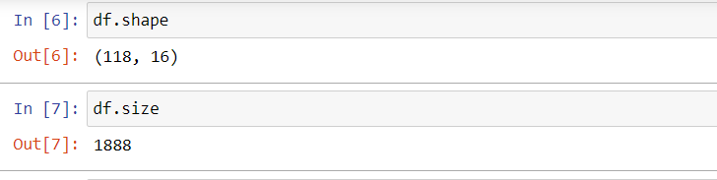

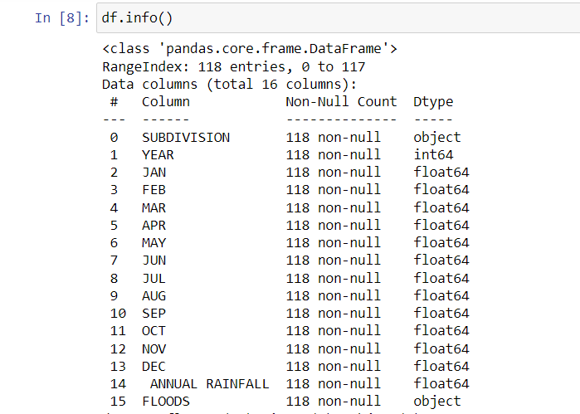

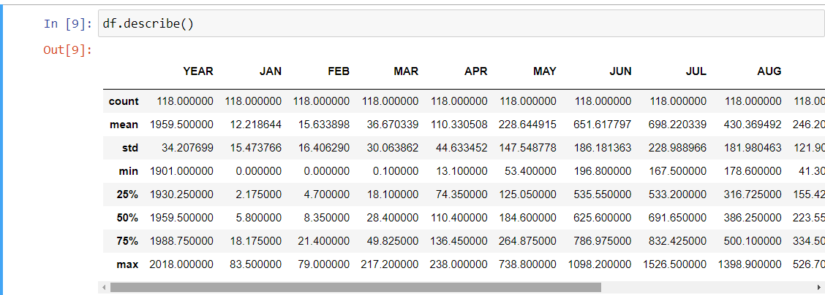

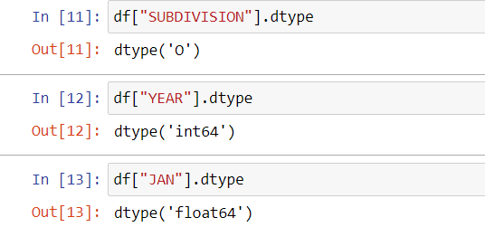

**Now we want to know about our data whether it has null values or not. If it has null values we should preprocess the data using normalization, data formatting, and bining**.

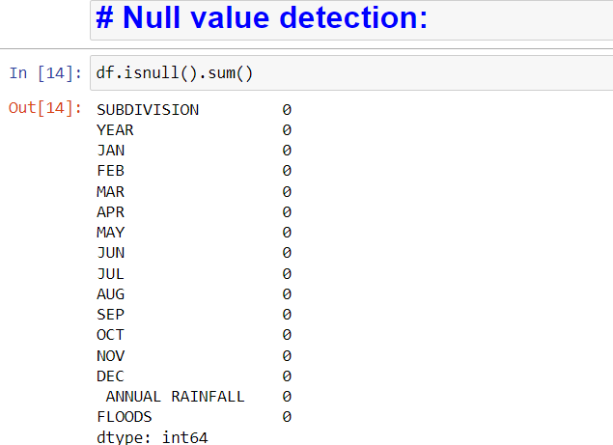

We don’t have any null values. So we don’t need to preprocessing the data.

Our dependent variable have YES or NO these are object type so we want to change the values into binary .

Data processing:

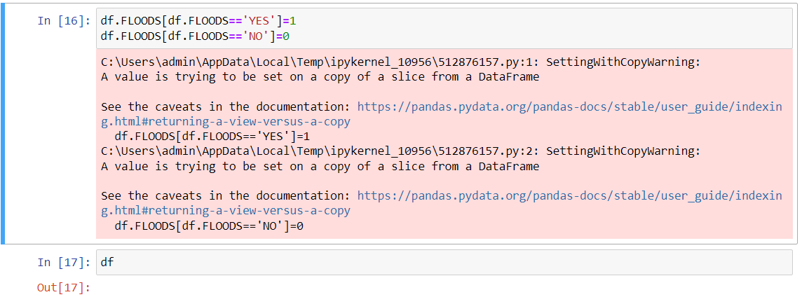

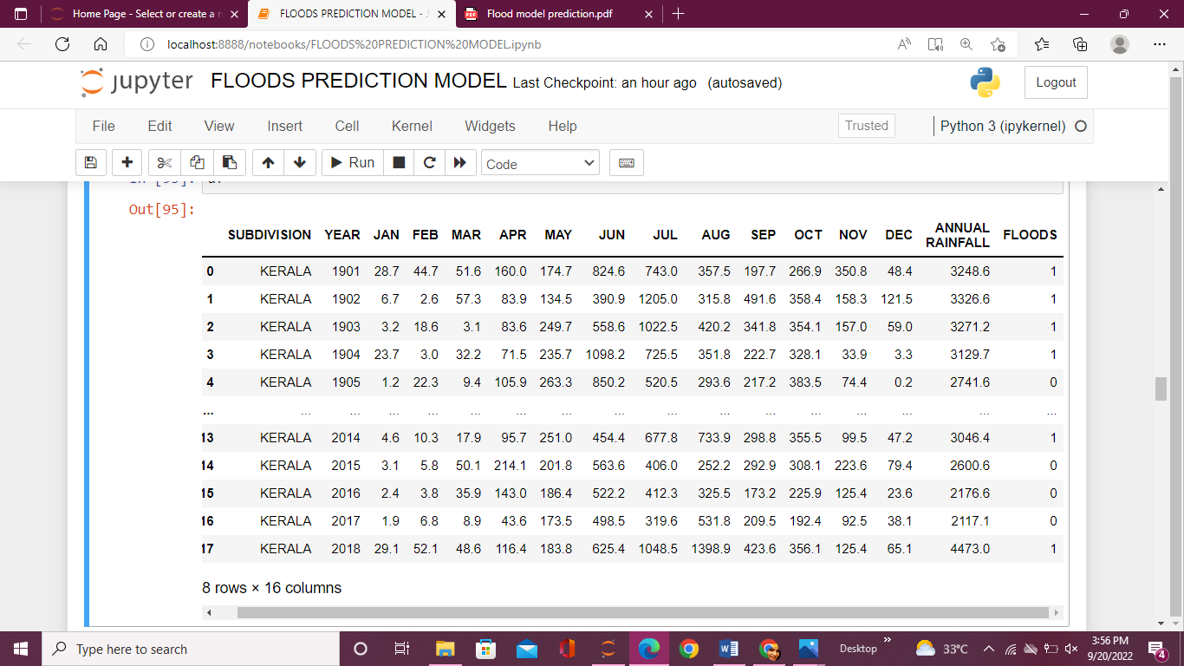

It change the yes or no values into binary values.

Now our dataset is ready with not have any null values.

Data visualization :

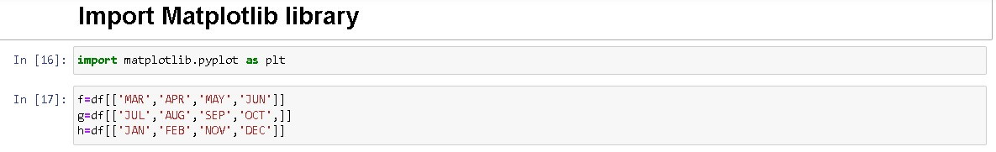

In this I visualize the data in seasonal way

In summer season the variation of rainfall is shown in below.

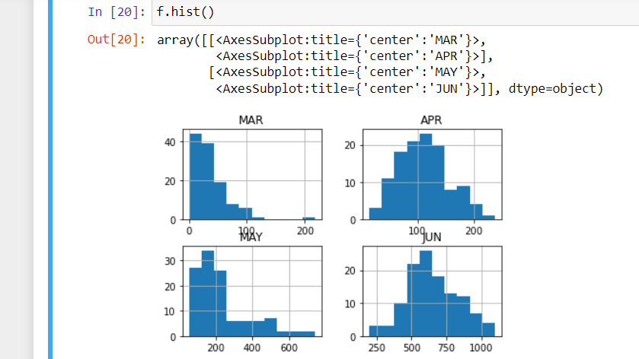

Next rainy season

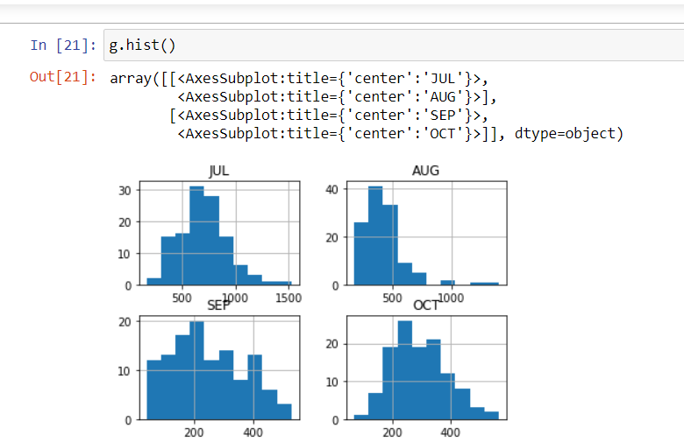

In this, we observe September have heavy rainfall during rainy season .

Next the winter season

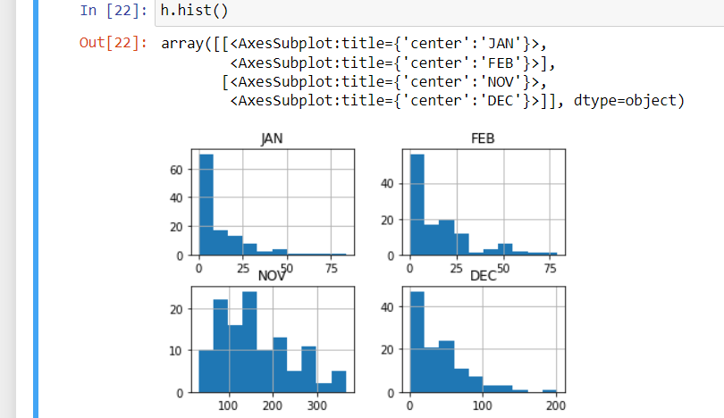

**CREATION OF MODEL:**

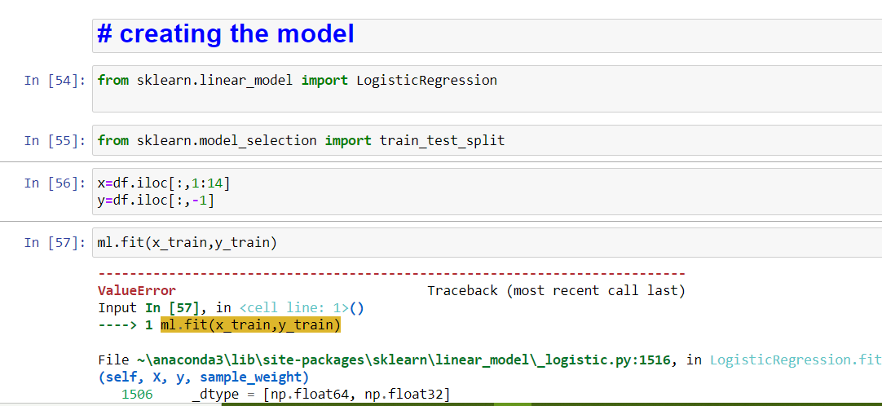

Training the data :

Next we import test and train split using this split the data into training data and testing data.

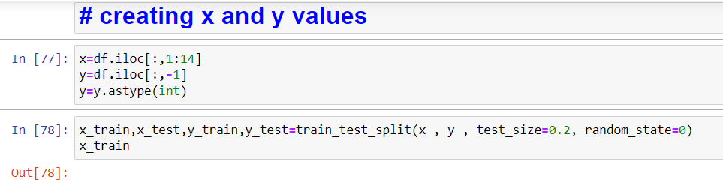

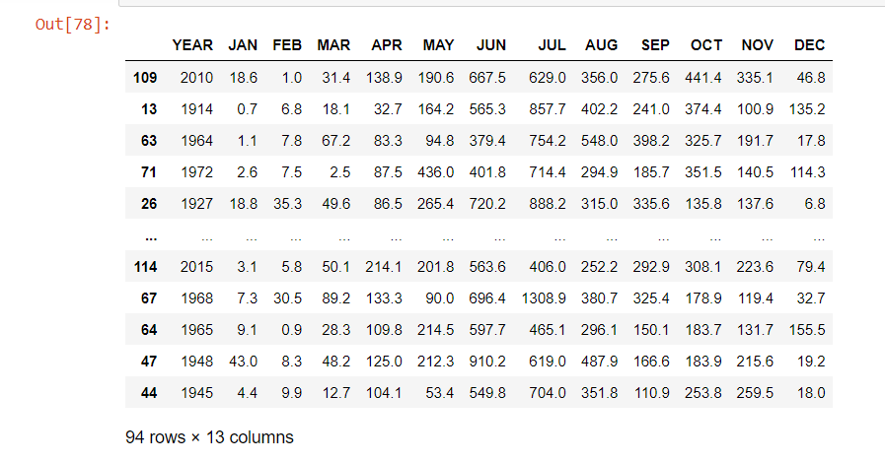

In this I give test_size=o.2 instead of that we give test size also.

So the data is divided into

80% for training data.

20% for testing data.

Logistic Regression :

Then predict the values of y.

Predict the Y values &

Difference between predicted values and original values:

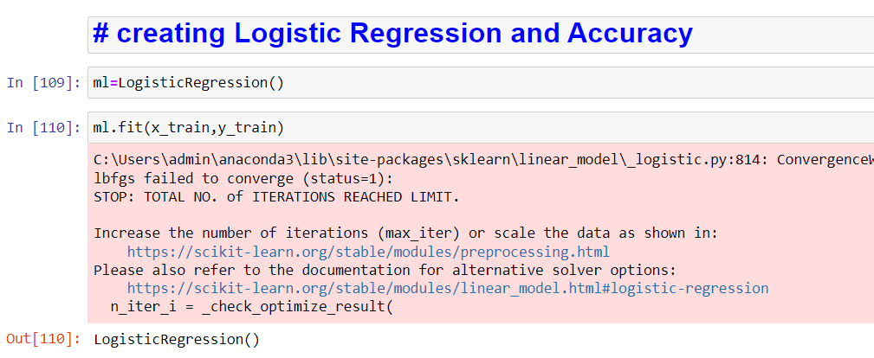

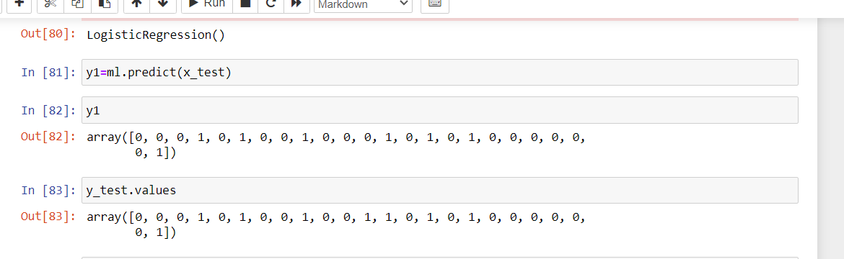

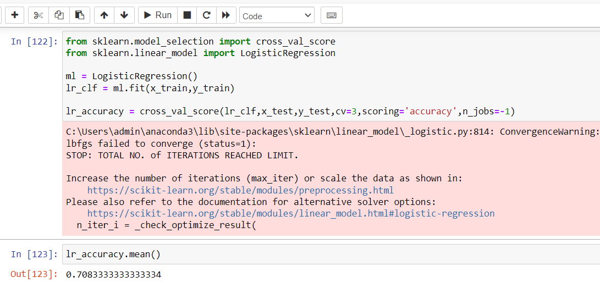

LogisticRegression model accuracy is 0.708 i.e 70 % accuracy it have.

Lets Predict the new values :

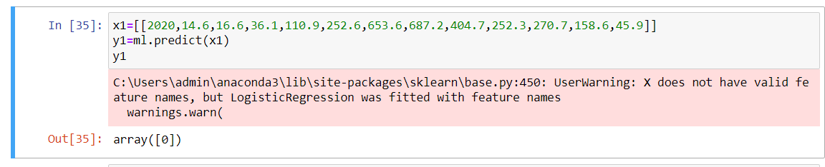

Here the x1 new value – predicted value is 0 means NO.

In this way the model work for FLOOD PREDICTION.

REFERENCE:

1)https://www.kaggle.com/datasets/mukulthakur177/kerela-flood

2)

Projected by

Name: Y.Bhavani

Class: (CSE-2A)

Id : S180374